Acceptance Test

ID – 5

1. Create a new game with the easiest difficulty

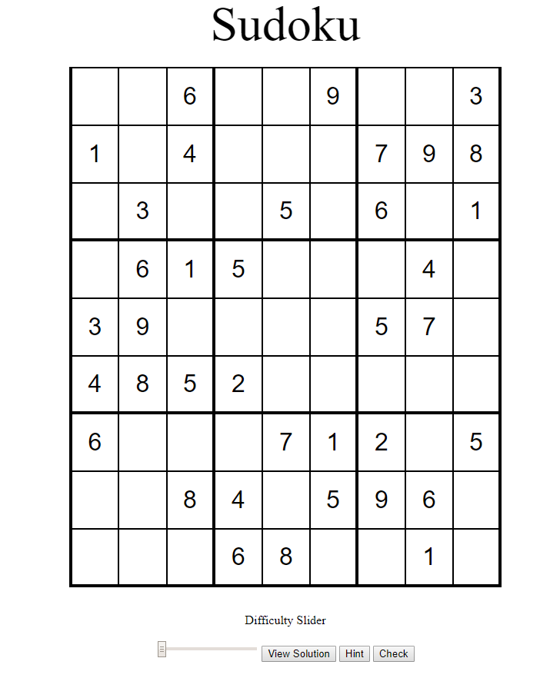

1. Create another game with the same difficulty

